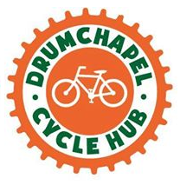
Drumchapel Cycle Hub - Covid-19 response
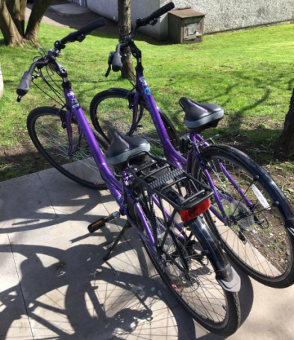
Never has the time we spend outdoor exercising been so precious. As people try to get their daily activity while staying safe and observing social distancing guidelines, Drumchapel Cycle Hub have offered a range of services to people in the local community including bike safety checks and maintenance as well as a bike loan scheme where individuals and families can borrow a bike to travel to work or enjoy a cycle.

"We wanted to contribute something positive to the local community during this challenging time. We have a fantastic resource which has been well received, we hope it helps people to stay active and healthy"
Anne Glass, Drumchapel Cycle Hub

Range of bikes available to loan
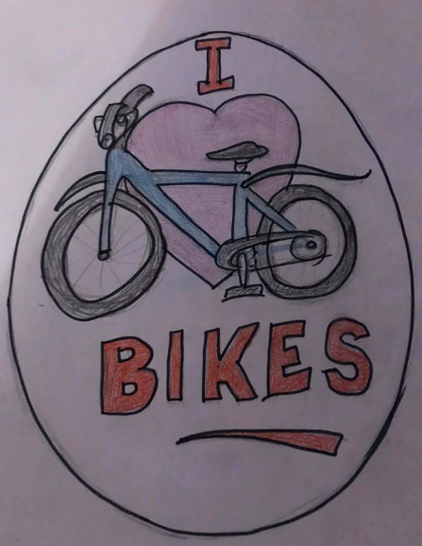
The social side of the Cycle Hub has always been at the heart of the activities. The hub has continued to keep in touch with members by replacing weekly rides with online quizzes and art competitions for younger members.

Easter Art competition entry

