**Winter Trail – Find, draw, write**



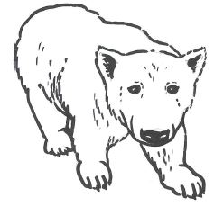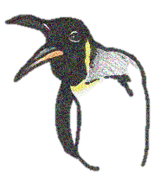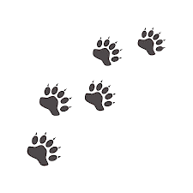

**North America**

**Find the Polar Bear from North America and read the labels to discover how it keeps warm**

**Draw more bear footprints beside it**

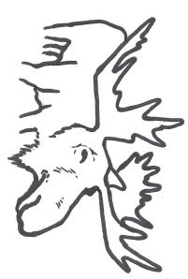

**How do Penguins keep their eggs warm?**

**________________________________**

**This King Penguin has lost its young!**

**Draw a chick beside it with warm feathers**

**Antarctica**

**Find the Seals that live in this cold continent.**

**What is their warm thick layer of fat called?**

**_____________________**

**Draw a SEAL body shape around the little face**

**Why does the Moose have such long legs?**

**____________________________________**

**Draw some very long legs on this one!**

**Why is their top lip long and flexible?**

**____________________________________**

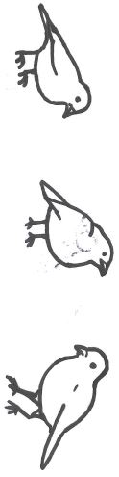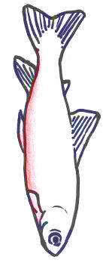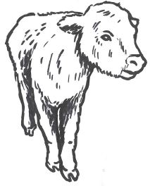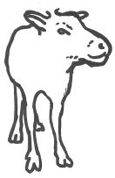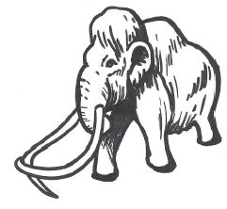

**In the large cabinet, find a little Arctic Charr fish with a RED belly.**

**What does it eat?**

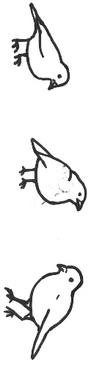

**Scottish Wildlife Gallery**

**How many winter birds can you see?**

**_______________**

**Well Done! You have completed the trail**

**Creatures of the Past**

**Find the Reindeer.**

**There are no wild Reindeer in Scotland anymore because of the warming climate.**

**Which country brought a herd to the Cairngorms in 1952? _____________________________**

**This one is missing its Antlers! Draw some on its head**

**This Highland Calf has 2 layers of fur. What for?**

**OUTER LAYER _________________________________**

**SHORTER UNDERCOAT __________________________**

**This creature died out during the ice age**

**We have a small model but a real one would have been HUGE! What is it called?**

**___________________**

**Which body parts were found in Scotland? _________________________**