Media Release
From Susan Flockhart
Phone 07990 523772
Email susan.flockhart@glasgowlife.org.uk

GLASGOW LIFE ISSUES AN OPEN CALL FOR 23 ARTISTS IN RESIDENCE TO WORK IN COMMUNITIES ACROSS THE CITY

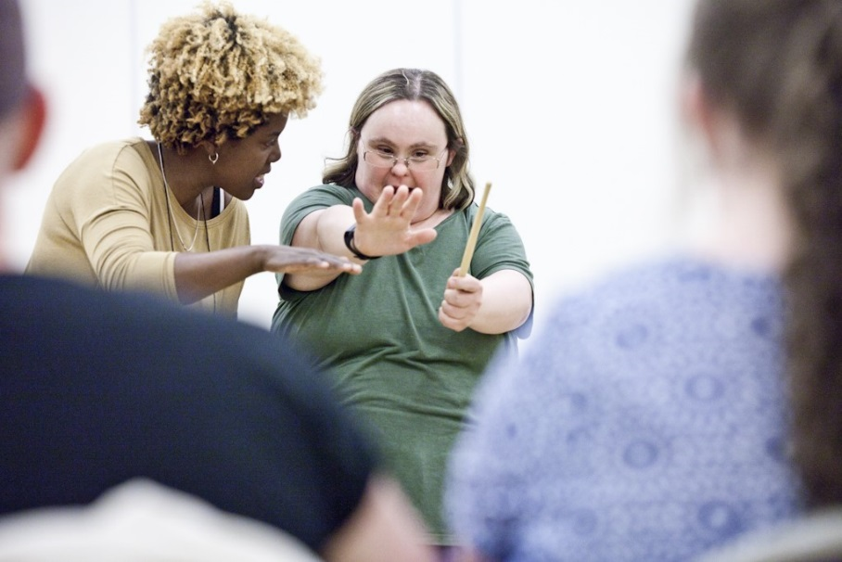
Tina Freeland facilitates a percussion workshop in Calton (Ward 9) as part of Phase One of Glasgow’s Creative Communities programme
(Photo by Robin Mitchell)

Glasgow Life is searching for 23 imaginative artists with the vision and skill to help local communities reap the life-enhancing benefits of creative activity. Choreographers, writers, dramatists, filmmakers, musicians, photographers and others are being invited to apply to become artists in residence, as the second phase of Glasgow’s ambitious Creative Communities programme gets underway.

The organisers hope to encourage practitioners from a wide range of art forms, from painting to embroidery, from Gaelic singing to hip hop or Bhangra … and everything in between.

Creative Communities – Artists In Residence aims to give Glaswegians from diverse backgrounds, the opportunity to get creative within their local area. Set up following a 2018 Culture Summit, when Glasgow City Council pledged to employ “an artist in residence in every community”, this £400,000 council-funded programme is being delivered by Glasgow Life, the council-linked charity responsible for culture and sport.

The programme kicked off last year, with a preliminary consultation that saw 23 artists and arts organisations each spending three months immersed in one of Glasgow’s 23 wards.

Coming from a wide range of disciplines, those artists used craft, music, drama and a myriad of other techniques to engage with community groups and individuals. In the process, they generated important conversations about what local people wanted from the programme.

In the Linn ward, people from Castlemilk and Carmunnock worked with a textile artist to create a huge “ideal shopping list”, embroidering and inking their aspirations for their neighbourhood onto a large piece of cloth.

Creative photography workshops in Shettleston allowed young people to compare images of the area’s past and present, and to think about its heritage and future needs.

In Dennistoun, residents worked with a theatre-maker to create musical playlists which expressed their wishes for their home area. On the south side, people shared local stories and knowledge through a community-based snakes and ladders game. And so on across the remaining 19 wards, where artists used film, storytelling and various other means to consult imaginatively with communities.

Now that creative listening exercise is complete, Glasgow Life wants to go further in helping local people to unleash their creative potential, by appointing 23 artists in residence: one in each council ward area.

Each will spend six months working within a community, building on the responses and recommendations gathered during phase one to foster creative involvement. Schoolchildren, people from diverse cultural backgrounds and abilities, as well as those who lack opportunity to participate or engage in the arts, are among those expected to benefit.

The aim is to create meaningful artworks and activities that are in tune with local needs and which positively enhance the lives of people living in those communities. It’s expected that some of the works will reflect important moments in the city – from community gala days to major events such as COP26 – the 2020 United Nations Climate Change Conference, which takes place in Glasgow in November.

To this end, Glasgow Life has issued an open call to artists or arts organisations. Applicants must be based in Scotland and emerging artists, as well as highly experienced practitioners, are invited to apply, and the programme is open to individuals and groups from a wide range of artistic disciplines.

“Successful applicants will be expected to build on the community recommendations that were generated during phase one of the programme,” explains Councillor David McDonald, chair of Glasgow Life and Depute Leader of Glasgow City Council. “Working in collaboration with local community groups and individuals, they will facilitate the creation of dynamic and imaginative artistic activities that enhance the life of each community.

He adds: “It is well known that involvement in the arts enriches people’s lives and can boost health and wellbeing. That’s why we at Glasgow Life are determined to extend opportunities for creative engagement to as many people as possible.

“Our Creative Communities programme is designed to do exactly that, and the achievements of local people and artists during the first phase were impressive. I’m really looking forward to watching that creative potential being extended during phase two. I have no doubt that the results will be surprising, and inspiring.”

The Open Call comes at the start of a year during which Glasgow’s 25-year Culture Plan will be finalised and published. The six-month residencies – which are expected to run from April to November 2020 – will each be backed by a £12,000 fee, plus support for materials. Artists are being invited to submit proposals for a specific area, and to explain how the fee would be used.

Full application details are available at www.glasgowlife.org.uk/creative

