Hieroglyph Translation

Now you are going to translate an inscription that was written down when the pyramids were being built – four and a half thousand years ago.
You need to remember everything you have learnt about hieroglyphs already…

Your Challenge:
Look at this picture. Can you see the hieroglyphs? Your challenge is to work out what they say.
This is called a stele and it was put in the tomb of a very important Egyptian man who lived around 2500 BC.
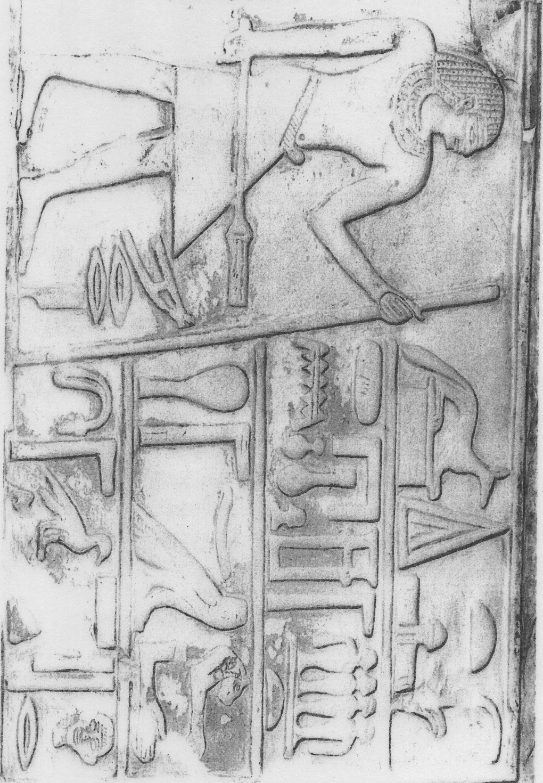
First of all, check where to start reading… can you remember how to tell whether you read from left to right or backwards?

Now look at the translation page. I’ve split the hieroglyphs into groups like before. The translation for each group is directly underneath it. You just need to put the groups in the right order.

It might help to cut out each group so you can lay them out.

This stele is in Kelvingrove Museum in Glasgow and I’m afraid I don’t have a better photo but part of this is damaged so some groups might not look exactly like the drawn-out hieroglyphs but you should be able to work out what goes where.

Egyptologists often have to guess what missing parts of an object might be… after thousands of years, things from ancient Egypt are often broken or not complete.

Can you draw on the picture to complete the damaged hieroglyphs?

Translation Page:
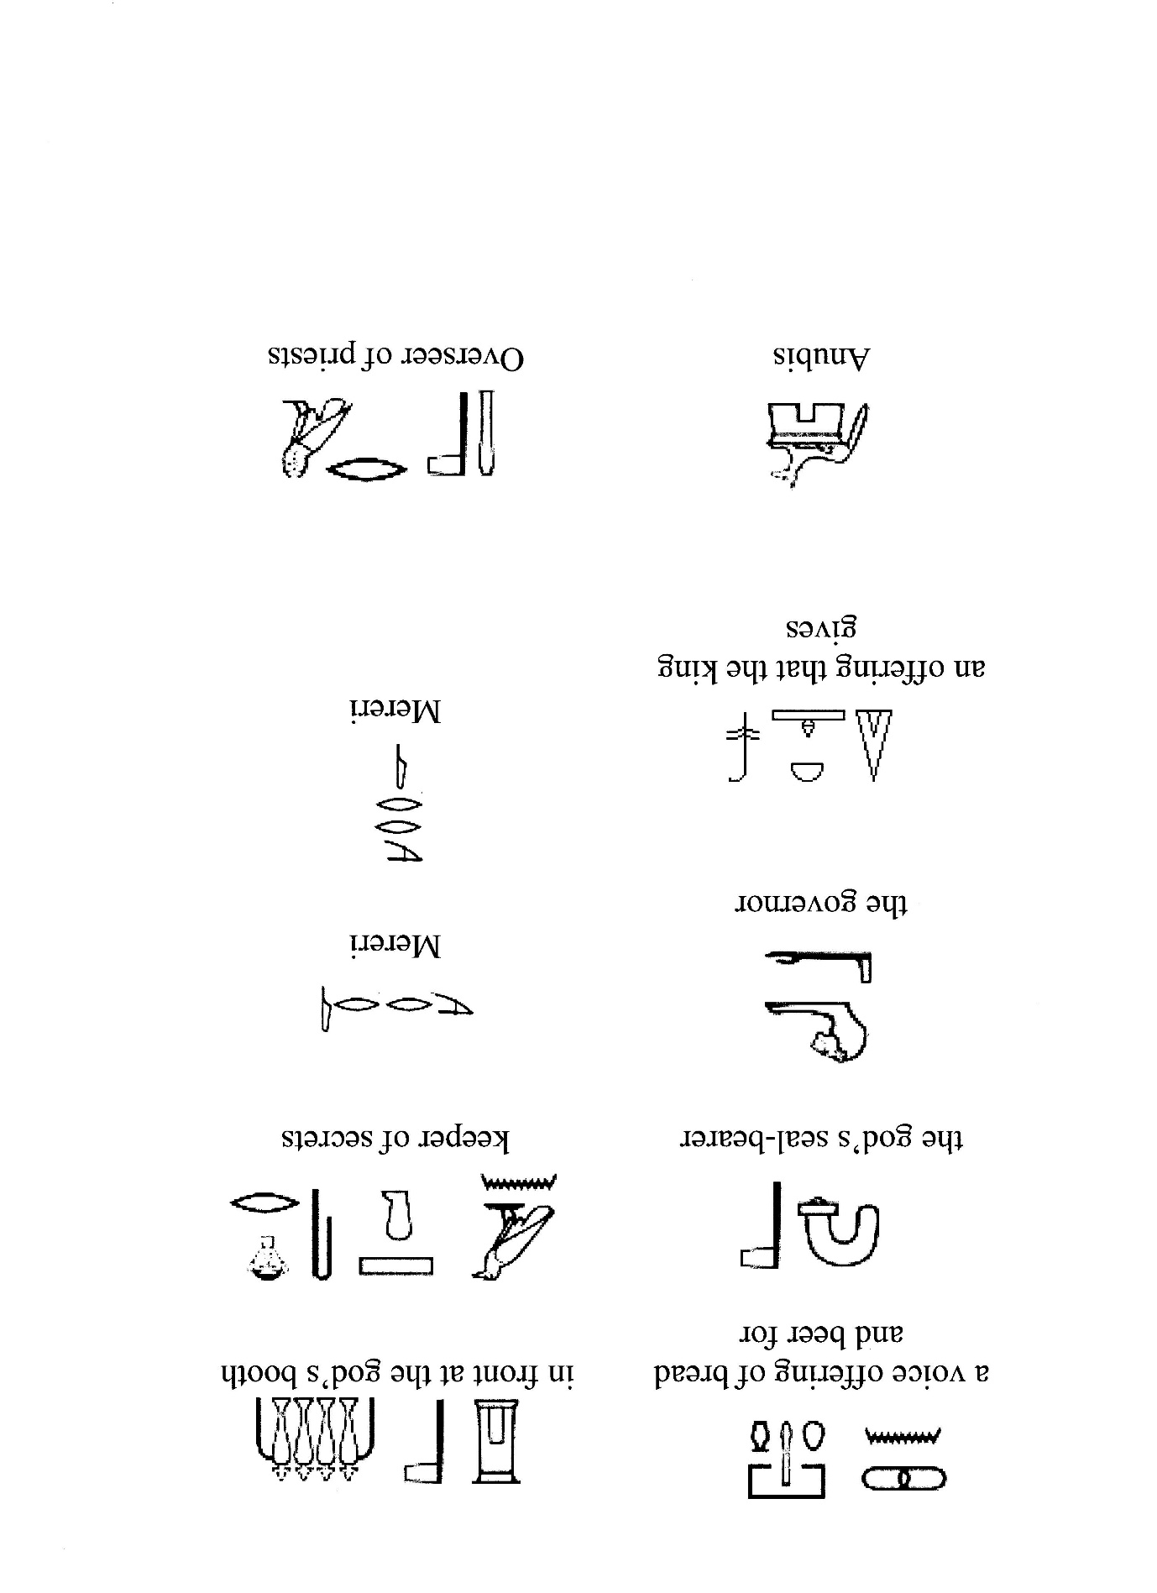

Answers: (Read from the top row first from right to left and then down to next row)
The Egyptians believed that only the king could talk directly to the gods so offerings had to come from him.

This is the name of the man in the stele. The hieroglyphs are m-r-r-i. Egyptians didn’t usually write vowels and so we have to guess. We say “Mereri” but his name could be Marari, Mururi or Morori.. what do you think is right?

Important documents had a special stamp on them and this man had the stamp for the god… which means the king. (The Egyptians thought their king was a god).

This was another important job which meant that you were in charge of priests in the temple.

The king only trusted a few people who could write down what he wanted – they were keepers of secrets… we call them secretaries.

Being a governor in ancient Egypt meant that you were in charge of a large part of the country.

A “voice offering” is a prayer… bread and beer were the first two things an Egyptian asked for in the afterlife!

The God’s booth was the part of the temple or holy place where the Egyptians believed the god lived.

Anubis was the Egyptian god of the dead.

