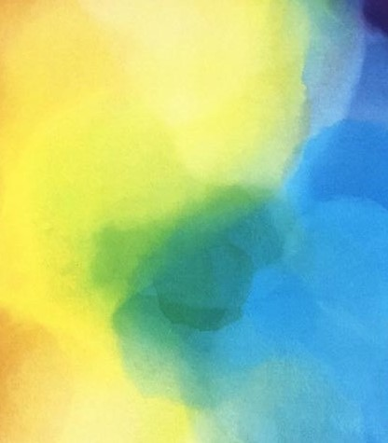

**mix**

colour mixing

**PRIMARY COLOURS!**

The lady above has a beautiful **RED** hat on.

She has a bright **YELLOW** skirt on.

Her jacket is **GREEN**.

**GREEN** is not a **PRIMARY COLOUR**. What other colour did the artist have in his palette to make the **GREEN**?

Can you paint a picture of someone wearing all **THREE PRIMARY COLOURS**… and mix up a **GREEN** colour to use as well?

*Artwork: The Lady with a red hat by William Strang*

**Glasgow Museums**

**Primary Art - Drawing School**