**Glasgow Museums**

Expressive Artwork Study for National 5

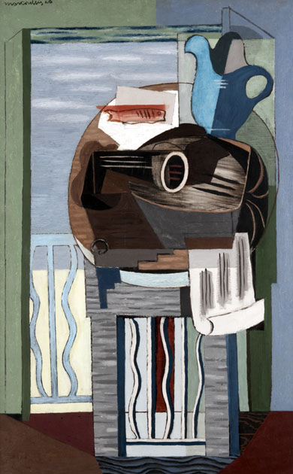

Artwork ID: 2902. © CSG CIC Glasgow Museums

**observe**

*Still Life In Front Of A Balcony* 1928 by Louis Marcoussis

Oil Paint on Canvas (100x 65.1cm)

Artists have often experimented with new ways of representing everyday objects.

Comment on how the artist has responded to this Still Life. In your answer refer to:

* Composition
* Shape
* Colour

What is your opinion of this style of painting? Give **two** justified reasons.

**write**

Flipping of Objects

Colourful

Harmonised

Title/Artwork Meaning

Cubist

Collage ‘Looking’ In Style

Crowded

**PERSONAL OPINION**

Impasto

Bold/Muted

Impact of Colour Use

Tones

Colour Creates Texture

Exaggeration

Repeat Patterns

Fine Detail

Definition of Shape

Describes Perspective

Flattering of Forms

Simplification

**Shape**

Crowded/Busy

Overlapping

Garish

Your Opinion

Unrealistic

How Successful is the Painting?

Viewpoint

Focal Point

**COMPOSITION**

Contrasting Colour

Backdrop

Vertical Line

Division of Space

**COLOUR**

Stylisation

Creates Pattern

Flat Areas of Colour

Colour and Focal Point

**Glasgow Museums**

Planning Your Answer

How do I describe what I see?