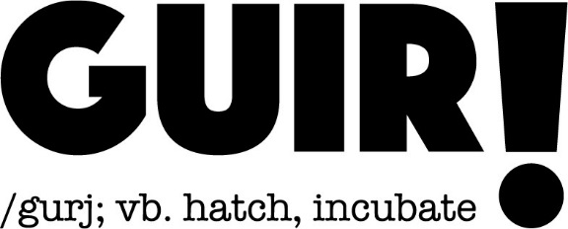

Call-out for Artists & Organisations working in Gaelic Contexts

In recent years Glasgow Life has played an important role in creating and developing work for diverse artists interested in experimental approaches to Gaelic artforms. Now in its third incarnation, GUIR!, the incubator programme with a collaborative model to develop new Gaelic work across disciplines, is making a CALL-OUT to artists. It is an opportunity to research and develop Gaelic Art practices and forms in the early stages of project development. Based on the equivalent of a 3 week residency period, with a 3 day Gaelic Cultural immersion (online) experience, it is an exciting opportunity to develop new, challenging and embryonic ideas to the next stage of development.

We are inviting proposals for ideas that respond to one or more of the following criteria:

- early stage idea generation
- previously unheard or hidden stories from Gaelic communities in Glasgow
- projects that will open up new pathways for creativity within Gaelic Culture
- projects that encourage collaboration with other artists, organisations or the Gaelic sector
- responses to the current challenges with the Gaelic vernacular
- projects from a wide range of art-forms including storytelling, ceilidh, literature, music, dance, drama, live performance, new writing, craft, film, animation, visual arts, and digital formats which artists are newly working with in response to Covid-19
- projects which respond to COP 26 from a Gaelic perspective
- Projects that could potentially align to city wide initiatives such as Creative Communities: Artist in Residence programmes across all art-forms.

The Covid-19 crisis has thrown up unexpected challenges for everyone including artists and communities. It is for this reason that this year GUIR! will encourage a focus on work that can be developed via digital means. Glasgow Life remains committed to continuing to provide work and income for artists wherever possible. The ideas should follow all Scottish Government restrictions for managing Covid-19, and for the most part be virtual. As this is an incubation project it may work towards another stage of your project, outwith this funding, which can be developed when restrictions are relaxed.

To submit a project idea, please fill out the application form and return it with an accompanying CV to: GL.learningteam@glasgowlife.org.uk. If you’d like any more information or would like to discuss an idea please contact us on the same email. Deadline for submissions 5pm Sunday 14th March 2021

The residency must take place during the Month of May 2021 and all successful applicants must be available for the online sessions on 12-14th April 2021 (9:30-3:30pm)

Successful applicants will be informed by 20th March 2021

- Up to 3 projects will be selected for delivery in May 2021
- There will be a budget of up to £3000 per project + additional in-kind support
- Successful artists will participate in an 3 day on-line immersion course and must be available to attend on 12-14th April 2021 (9:30-3:30pm)
- It is open to Gaelic-speaking (any level) artists and non-Gaelic speakers with a vested interest in Gaelic culture
- If you are non-Gaelic speaking some of your fee should be allocated to a Gaelic speaking artist(s) with whom you’d like to work
- Depending on the nature of your idea, an in kind support package may be developed for each project with the help of partners and within current restrictions
- An online support model will be in operation throughout the incubation period to support the development of your work
- A discreet budget may be allocated e.g. towards online production costs or materials
- Projects will be documented with an aim to develop the GUIR network
- The idea cannot be an already an existing project or previously developed idea
- The idea should culminate in a sharing (discreet or open) that is available in a digital format.

GUIR! is delivered by Glasgow Life and part of the Gaelic Arts Strategy.
for Glasgow City Council’s Gaelic Language Plan. GUIR works in partnership with The National Theatre of Scotland, Sabhal Mòr Ostaig, Royal Conservatoire of Scotland and Tramway. GUIR! is funded with support from Bòrd na Gaidhlig.

