VISUAL ARTIST & CRAFT MAKER AWARDS: GLASGOW

2023-24 Bursaries

APPLICATION FORM

VACMA: GLASGOW is funded through a partnership between Glasgow Life and Creative Scotland

 | 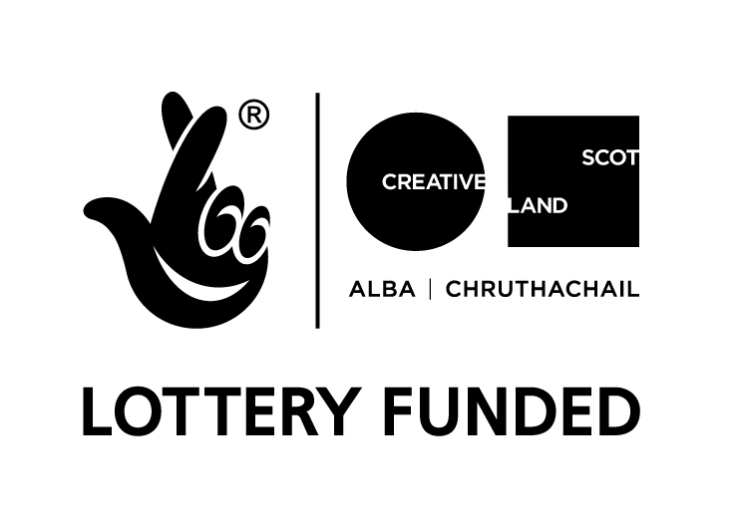 | 

Visual Artist and Craft Maker Awards: Glasgow
in partnership with Creative Scotland
#VACMAScotland

Please ensure that you have read the guidelines carefully before completing the form.

Applicant Details
Legal Name (for finance and contracting purposes):

Preferred Name (if different from your legal name):

Pronouns (optional):

Address (including postcode)

Contact telephone number:

Email:

Website:

Project start date:

Project end date:

I am applying for (select one box only) | ✓
Artist Bursary £750
Early-Career Bursary £500

Artform (select one box only) | ✓
Visual Art
Craft

Summary
Please briefly summarise the project or activity which you are seeking funding for. Max 30 words. (Please note that we may use this text for marketing and communications purposes if you are successful).

About You
Please tell us briefly about your creative practice.
What does your practice involve and why do you do it? Max 250 words

What would the bursary support you to do with your creative practice at this time? Max 500 words

How will this develop your skills/practice, support experimentation and contribute to your future ambitions? Max 250 words

Please give an outline and timetable (including dates) of the key stages of your proposed activity and any preparation work you have done.

Is there any public element to the proposal? Max 200 words
If so, please tell us what it will involve and how you will reach or engage people.

Please give an outline of any risks you have identified in delivering your activity and tell us how you will mitigate them.

Equalities, Diversity and Inclusion (EDI)
Please tell us how you will consider the principles of Equalities, Inclusion and Diversity (EDI) within your proposed activity and/or wider practice? If you have experienced any barriers that impact on your practice, you can tell us about them too. (Max 250 words)

Environmental Sustainability
Please tell us how you are responding to the climate emergency and the environmental impact of your proposed activity and/or wider practice. (Max 250 words)

Previous Applications
Have you had a VACMA, or Creative Scotland award before? If so, when? If you have, please tell us how that support helped your practice, and whether this is a continuation of that project. (Max 150 words)

Please note that priority in awards may go to those who have not previously been successful in the scheme. Applications will not be considered from previously successful applicants who have not submitted their End of Project Report.

Place
Do you live in the local authority area that you are applying to?
If you are not a resident, tell us why you are applying to this scheme. Please note that applications can only be accepted from artists and makers who live, work or hold a studio in the local authority area that they are applying to.

Budget
As we are offering fixed bursaries, we do not require a full budget. Partnership income is not a requirement of the fund but if the VACMA bursary is only covering a portion of your costs you will need to tell us where the rest of the income is coming from. You can also tell us about any in-kind contributions in the table below.

Income
Source | Amount | Is this cash or in kind?
Grant request: £750 or £500 |  | Cash
Own cash contribution (if applicable)
Other sources of income (if applicable)
Total Estimated Income

Artwork Submission Form
Please enter details of the artwork submitted in support of your application. We cannot accept original artwork. All supporting material should be clearly labelled with your name and the title of works.

 | Image / Work Title | Date | Dimensions | Medium and Description
1
2
3
4
5
6

Please note that we cannot accept hard copy material. All supporting material should be sent as electronic files. If sending images or videos, please be mindful of the size of files. You may wish to compile these in a single document such as a PDF or include weblinks.

Supporting Information – Check List
Please make sure you include the following documents when you submit your application.

Please submit a copy of your current artist CV  This helps us to understand what your experience to date. You can also include an artist’s statement if you wish. | Y/N
Letter of confirmation/support (where applicable)  For example, if you are applying for the development of work for an exhibition or to participate in a residency, the panel will want to know what support the gallery / host organisation is providing. | Y/N
Examples of work  You should submit up to 6 high quality images or up to 3 minutes of film/sound files. | Y/N
Equalities Monitoring form  This form is anonymous and will be processed separately and has no bearing on your application. If you do not know some of the information or if you prefer not to provide it, you can fill in the ‘Prefer not to answer’ box. | Y/N

Use of Your Information
We are committed to protecting the rights and privacy of individuals in accordance with the Data Protection Act 2018. We need to process certain information about our staff, customers, and other individuals that we have dealings with for administrative purposes. We will also share the information provided with Creative Scotland as the funding partners to support evaluation, assessment and development. To comply with the Act, information collected about individuals must be used fairly, stored safely and securely and not disclosed to any third party unlawfully. Data Protection Act - The DPA 2018 sets out the framework for data protection law in the UK. It updates and replaces the Data Protection Act 1998, and came into effect on 25 May 2018. It sits alongside the GDPR, and tailors how the GDPR applies in the UK.

Privacy Notice
We are committed to protecting the rights and privacy of individuals in accordance with the Data Protection Act 2018. You can find out how we handle personal data at https://www.glasgowlife.org.uk/the-small-print/privacy-glasgow-life

How To Submit Your Application

Completed applications should be emailed to gl.learningteam@glasgowlife.org.uk

Applications should be submitted by email by the closing date. Along with your emailed application form six images of recent work (no more than 4MB in total) should be attached.

When submitting your application, please ensure you send it as an email attachment rather than via a web hosting service. Please note, we are unable to accept documents in a Zip File. Applications must be emailed and not posted. There is no facility to hand deliver hard (paper) copies of applications. Please don’t send applications or artwork in the post.

There will be two funding rounds in 2023/2024, the closing dates are:

Autumn Deadline
Tuesday 24th October 2023 @ 5.00pm

Winter Deadline
Tuesday 6th February 2024 @ 5.00pm

We are unable to accept late applications. Your application will be acknowledged within five working days. If you don’t receive an email confirming receipt of your application, you must contact us at gl.learningteam@glasgowlife.org.uk

Declaration
I (full name) _____________________________________ hereby apply for financial assistance towards the cost of undertaking the project described in this application. To the best of my knowledge and belief, the information given is correct.

Signature
Date

