Tramway opens its 2023 visual arts programme with an exhibition by Nigerian artist Ifeoma U. Anyaeji who transforms discarded plastics into distinctive sculptures.
Ijem nke Mmanwu m (The journey of my masquerade)
Preview: Friday 3rd March 2023, 7pm-9pm
Exhibition runs 4th March until 4th June 2023
Tramway is pleased to open its 2023 programme with the first Scottish exhibition by Nigerian artist Ifeoma U. Anyaeji (born in Benin City). The artist creates colourful, intricately hand-crafted sculptures and installations from non-biodegradable plastics such as bottles and plastic bags. Applying a unique practice which she describes as Plasto-art, Anyaeji experiments with these global pollutants, binding the plastic with thread into woven braids and transforming them into vibrant, malleable textiles. Anyaeji uses a Nigerian hair-plaiting technique called Threading (Ikpa Owu in Igbo language), an increasingly obsolete hair-craft. These plastic braids are shaped and layered into densely textural sculptural forms which encapsulate vibrant colours, spirals, coils, circles and loops. Combining hair threading with traditional West African basketry and fabric weaving techniques, Anyaeji reflects on the loss of such traditions as well as the environmental problems she encountered in her community in Nigeria.

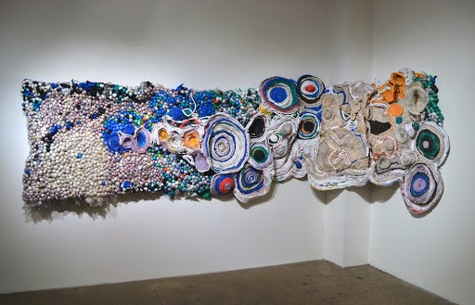

Ifeoma U. Anyaeji (2015) Eze Fuo eze anochie-When a king dies another replaces him. Plastic bags, wire, twine, mesh and bubblies

Weaving together personal and collective experiences, her distinctive and vibrant sculptures also embrace forms and influences from West African Culture, specifically the performance, folklore, music, textiles and the domestic and communal spaces of Nigeria. In a new commission created for Tramway Anyaeji references the Nigerian Masquerade, traditionally only performed by men which involves the use of elaborate, colourful costumes that are meant to invoke ancestral spirits. Anyaeji re-imagines this masculine ritual in sculptural form using traditionally feminine craft practices, exploring gender-categorized craft and decorative art as viable means of artistic expression, as well as political and subversive potential.

The artist explains, “ I was immediately drawn to the use of waste to create these larger-scale sculptural forms, to make something beautiful that has something to say about our environment and material reuse. References have also been made to the human body, architecture and domestic spaces. This idea that the sculptural forms are never complete was interesting as the pieces are often adapted, re-edited and reworked so they are always in process”

They added “I constantly reflect on the implications of our modernity’s: consumptive systems of mass accumulation, waste generation or social attitude to value and the expiration-date syndrome, cultural assimilation and colonial orientations on beauty, authenticity and newness. In addition to metaphorically and spontaneously engaging these “old” plastic objects, I try to emphasize the potency of traditional crafting methodologies, highlighting the mark of the hand through supposedly menial obsolete techniques such as Threading and loom weaving.”

For press information contact Nicola Jeffs nj@nicolajeffs.com 07794 694 754

Funded by Creative Scotland

About Tramway
Tramway is part of Glasgow Life, the charity which delivers culture and sport in the city. One of Scotland’s leading international art-spaces, the venue acts as a hub for creative excellence in contemporary visual art and performance by developing presentation and production opportunities supporting ambitious commissions and the production of new exhibitions by both Scottish and International artists.
Visit www.tramway.org

About Glasgow Life
Our programmes, experiences and events range from grassroots community activities to large-scale cultural, artistic and sporting events which present Glasgow on an international stage. Our work is designed to promote inclusion, happiness and health, and to support the city’s visitor economy in order to enhance Glasgow’s mental, physical and economic wellbeing.
For more information, visit www.glasgowlife.org.uk

