Media release
For immediate release

ELIZABETH PRICE: SLOW DANS to open 2023 programme at Gallery of Modern Art Glasgow
Preview 26 January 6.30pm – 8pm
Exhibition runs 27 January – 14 May 2023
Gallery of Modern Art (GoMA)
Admission Free
- Scottish Premiere of SLOW DANS (2018 – 2019) by Turner Prize winning artist Elizabeth Price exploring class, patriarchy and labour to open 2023 programme at Gallery of Modern Art in Glasgow
- Ambitious and critically acclaimed moving image installation to be acquired by Glasgow Museums following presentation
This month sees the Scottish premiere of SLOW DANS, one of the most ambitious installations to date by Turner Prize winning artist Elizabeth Price. Presented by Glasgow Life, the charity that delivers culture and sport in Glasgow, the work will be shown in the prestigious main space at the Gallery of Modern Art (GoMA).
SLOW DANS is a cycle of three 10 screen videos – KOHL, FELT TIP, and THE TEACHERS. These three works present a fictional past, parallel present, and imagined future, interweaving compact narratives that explore social and sexual histories and our changing relationship with the material and the digital. Following the presentation at GoMA FELT TIP will enter the Glasgow Museums’ collection.
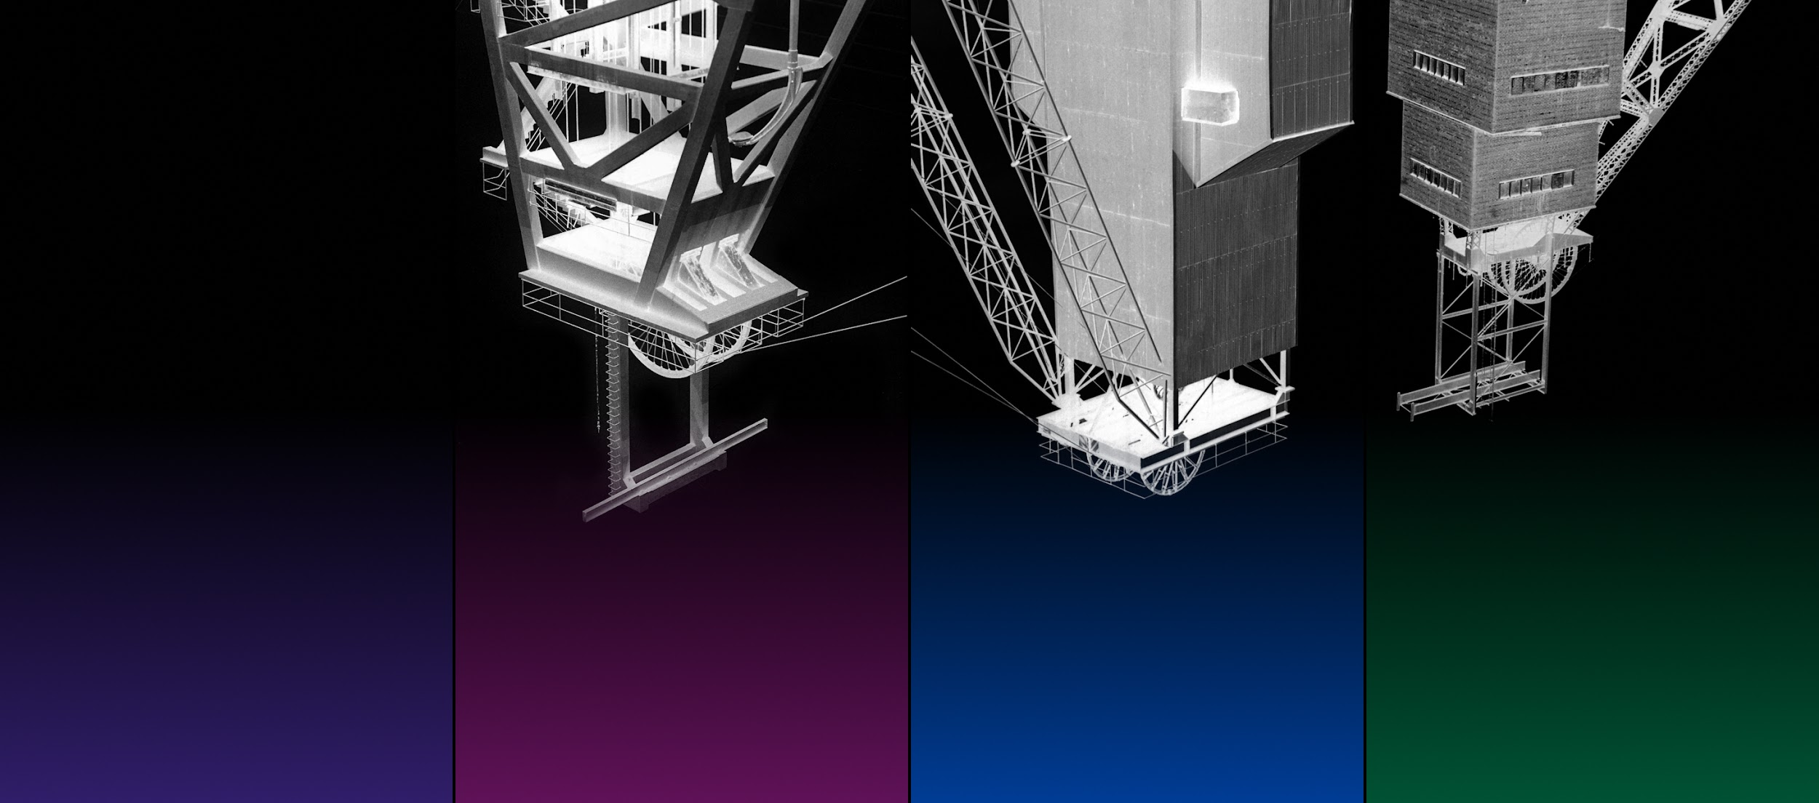

Elizabeth Price, FELT TIP, 2018
Commissioned by Artangel and Glasgow Life
Image © Elizabeth Price
Elizabeth Price is an internationally renowned artist with work in collections around the world. She has had solo exhibitions at Tate Britain, London, UK; The Walker Art Center, Minneapolis, USA; Chicago Institute of Art, USA; Julia Stoschek Foundation, Dusseldorf, Germany; The Baltic, Newcastle Upon Tyne, UK; and another exhibition - UNDERFOOT - currently in Glasgow at The Hunterian Art Gallery, University of Glasgow until 16 April 2023.
SLOW DANS is a collaboration between Artangel, Film and Video Umbrella, Nottingham Contemporary, the Whitworth, The University of Manchester, Walker Art Center, Minneapolis, and Glasgow Life Museums with previous iterations of the trilogy shown in Manchester (2019) and London (2020).
The physical layout of the installation expands on the subjects and themes of the video-cycle. The projectors are oriented vertically, standing in, at various points, for mine shafts, inkwells, the human throat, and the format of a book page. They sit at two different heights, representing spaces below and above ground, the relation between a hard drive and a desktop computer, the interconnections of our geological past and technological present, and explorations of social and economic hierarchies of labour.

KOHL features the archive of former miner Albert Walker, who photographed UK coal mine architecture between 1970 and 1990. Walker’s images are presented upside down and in negative, representing the erasure of these industrial landmarks from our landscape. They also gesture to what remains, mine shafts still descending to a vast network of tunnels.

In FELT TIP, Price uses a collection of men’s neckties to explore the changing demographics of the office workforce in the period 1970–90. The ties connect this social change to interrelated histories of writing, weaving and data storage. The phallic symbolism of the tie also recalls the ink pen nib, another representation of those who traditionally held the power to write our history.

The visual imagery of THE TEACHERS is drawn from photography of women’s formal wear featured in UK fashion magazines between 1969 and 1995. The dresses are elaborate, the models’ poses never natural. They use exaggerated gestures to demonstrate the distinctive features of the clothes. Removed from the context of the fashion magazine, these disembodied gestures acquire different expressive powers.
https://www.glasgowlife.org.uk/museums/venues/gallery-of-modern-art-goma/exhibitions-at-goma
Listings Information:
Elizabeth Price: SLOW DANS
Gallery of Modern Art (GoMA), Royal Exchange Square, Glasgow, G1 3AH
27 January – 14 May 2023
Free admission
Monday – Thursday & Saturday 10 – 5, Friday & Sunday 11 -5
#SlowDans
#ElizabethPrice
Credits:
Elizabeth Price, THE TEACHERS, 2019
Commissioned by Artangel and the Whitworth, The University of Manchester

Elizabeth Price, FELT TIP1, 2018
Commissioned by Artangel and Glasgow Life
FELT TIP and THE TEACHERS are part of the trilogy SLOW DANS, a collaboration
between Artangel; Film and Video Umbrella; Glasgow Life; Nottingham Contemporary;
the Whitworth, The University of Manchester; and Walker Art Center, Minneapolis.
Artangel’s commissioning programme is generously supported using public funding
by Arts Council England, and by the private patronage of the Artangel International
Circle, Special Angels, Guardian Angels and The Company of Angels.

THE TEACHERS and FELT TIP are part of The Artangel Collection, an initiative to bring
outstanding film and video works, commissioned and produced by Artangel, to galleries
and museums across the UK. The Artangel Collection has been developed in partnership
with Tate, is generously supported by the Esmee Fairbairn Foundation and The Foyle
Foundation and uses public funding from Arts Council England.

The exhibition at GoMA is supported by Creative Scotland.

Further Information
For press information contact
Nicola Jeffs
nj@nicolajeffs.com
07794 694 754
NOTES TO EDITORS
About the three films in SLOW DANS
KOHL, 2018
Four-channel video projection
Running time: 6 minutes

KOHL features the archive of former miner Albert Walker, who photographed UK coalmine architecture between 1970 and 1990. Walker’s images are presented upside down and in negative, representing the erasure of these industrial landmarks from our landscape. They also gesture to what remains, mine shafts still descending to a vast network of tunnels. This is the basis for a short ghost story, in which the tidal water running through these tunnels becomes an expressive medium, carrying sound from one mine to another. It also appears as inky discharges in the foundations of new buildings, echoing ‘inky spit’, the fatal symptom of miner’s lung disease. The story is conveyed by four narrators, the spectral ‘visitants’, via typewritten text. Each ‘voice’ appears within a separate projection, announced by a different keyboard sound. The only other visible trace of the narrators is a pair of feet, dancing slowly between the screens.

FELT TIP, 2018
Two-channel video projection
Running time: 9 minutes

Price has described this work as key to the cycle. In FELT TIP, she uses a collection of men’s neckties to explore the changing demographics of the office workforce in the period 1970–90. The ties connect this social change to interrelated histories of writing, weaving and data storage. The phallic symbolism of the tie also recalls the ink pen nib, another representation of those who traditionally held the power to write our history. The narrators of FELT TIP imagine a different pen, another body. They tell us of a near-future corporate realm where they are employed to store documents in their own DNA. As they do, they touch upon the technical histories of data storage and of the necktie, and the class and gender politics of office life. Their tale turns on a series of visual echoes, proxies and substitutions which are communicated through wordplay.

Woven ties and computer data storage do share a technical history – both are descended from the jacquard loom, a predecessor of computer-aided weaving. Many of the ties feature imagery and patterning that echo emerging computer technologies. Motifs that look like memory chips replace the crests and insignia that silently indicate social class.

THE TEACHERS, 2019
Four-channel video projection
Running time: 10 minutes
The visual imagery of THE TEACHERS is drawn from photography of women’s formal wear featured in UK fashion magazines between 1969 and 1995. The dresses are elaborate, the models’ poses never natural. They use exaggerated gestures to demonstrate the distinctive features of the clothes. Removed from the context of the fashion magazine, these disembodied gestures acquire different expressive powers. In the parallel reality of THE TEACHERS, the dresses stand in for the formal robes traditionally worn by men in academia, the clergy, and the law. A chorus of four narrators describes how silence has spread contagiously through these groups. Those affected refuse to communicate other than through ambiguous oral sounds, and exaggerated gestures.
The visual effects in THE TEACHERS were not created digitally but by animating props and light sources. The dresses were reprinted on lightweight bookwove paper, and laser cut to create delicate stencils. These printed paper sheets were rotated slowly in front of a camera, imitating a solemn dance – and also echoing the turning of book pages.
About the Artist:
Elizabeth Price is an internationally renowned artist with work in collections around the world. She has had solo exhibitions at Tate Britain, London, UK; The Walker Art Center, Minneapolis, USA; Chicago Institute of Art, USA; Julia Stoschek Foundation, Dusseldorf, Germany; The Baltic, Newcastle Upon Tyne, UK; and The Hunterian, University of Glasgow, Scotland.
In 2012, she was awarded the Turner Prize for her video installation The Woolworths Choir of 1979. In 2013, she won the Contemporary Art Society Annual Award with the Ashmolean Museum of Art and Archaeology in partnership with the Pitt Rivers Museum and the Ruskin School of Drawing and Fine Art.
Glasgow Life is a charity working for the benefit of the people of Glasgow. We believe everyone deserves a great Glasgow life and we find innovative ways to make this happen across the city’s diverse communities.
Our programmes, experiences and events range from grassroots community activities to large-scale cultural, artistic and sporting events which present Glasgow on an international stage.
Our work is designed to promote inclusion, happiness and health, as well as support the city’s visitor economy, in order to enhance Glasgow’s mental, physical and economic wellbeing.
For more information, visit www.glasgowlife.org.uk.

Gallery of Modern Art
Situated in the heart of the city centre, GoMA is Scotland’s most-visited modern and contemporary art gallery, displaying work that highlights the interests, influences and working methods of artists from around the world.
Visit www.glasgowlife.org.uk/museums/venues/gallery-of-modern-art-goma for more information.
ARTANGEL
Artangel produces and presents extraordinary art in unexpected places across London, the UK,
and beyond. For over thirty years, Artangel has generated some of the most widely discussed
art of recent times, including prominent large-scale projects with artists who have become
household names in the UK, including the likes of Jeremy Deller, PJ Harvey, Roger Hiorns,
Michael Landy, and Rachel Whiteread.

Recent Artangel projects include Taryn Simon’s An Occupation of Loss, Evan Roth’s Red Lines,
Heiner Goebbels’ Everything that happened and would happen, Jonathan Glazer’s short film
STRASBOURG 1518, made for the BBC, and Steve McQueen’s Year 3, in collaboration with Tate Britain and A New Direction.

Appearing anywhere from empty prisons to underground vaults, prime-time TV to the sky at
night, Artangel produces art that takes on a multitude of forms and appears in different places
to offer varying points of access and interaction to a curious public.

Artangel’s commissioning programme is generously supported using public funding by Arts Council England, and by the private patronage of the Artangel International Circle, Special Angels, Guardian Angels and The Company of Angels.

https://www.artangel.org.uk/

