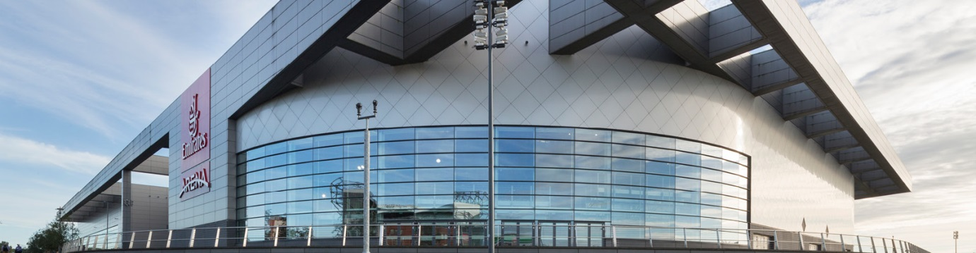

Sir Chris Hoy Velodrome

Velodrome
Guide

November 2023 to April 2024

Contents

Glasgow Life Velodrome Pathway 3
Youth Accreditation Pathway 4
Youth Sessions 6
Adult Accreditation Pathway 7
Try the Track Sessions 9
Coach Led Sessions 11
Sprint and Endurance Sessions 13
Paracycling 15
Track Events 2023/2024 16
November 2023 – March 2024 Price List 17

Sir Chris Hoy Velodrome

Glasgow Life Velodrome Pathway

Try the Track

Taster Sessions |  |  | Adult | Youth | Education Sessions |  | Paracycling
Club | Corporate | Youth Taster  (Age 8 – 10) | Family Session | Family Session | University | Schools | Paracycling  Session

Accreditation

Adult (Age 16+) | Youth (Age: 8 – 15)
Adult Accreditation 1 | Youth Accreditation 1
Adult Accreditation 2 Progression (4*) | Youth Accreditation 2 Progression (4*)
Adult Accreditation 3/4 (8*) | Youth Accreditation 3/4 (8*)
*Minimum number required

Ride the Track

Adult (Age 16+) |  | Youth (Age: 8 – 15)
Sprint & Endurance | Coach Led | Coach Led
DST Endurance | Adult Coach Led Tempo | Coach Led Youth Session
Sprint/Pursuit | Adult Coach Led Interval
 | Adult Coach Led Endurance
 | Adult Coach Led Sprint
 | Woman Only Session

Race

Track League | National Championships

Sir Chris Hoy Velodrome

Youth Accreditation Pathway
Age: 8 to 15
November 2023 to March 2024

 | Accreditation 1  (£10) 1 Hour | Accreditation 2*  (£10) 1 Hour | Accreditation 3/4*  (£19) 2 Hours
Date & Time | Saturday (10:00 – 11:00) | Saturday (10:00 – 11:00) | Saturday (13:00 – 15:00)
Block 1 | 04/11/23  18/11/23 | 28/10/23 | 18/11/23
Block 2 | 25/11/23  02/12/23  16/12/23  13/01/24 | 29/12/23  20/01/24 | Check APP for updates
Block 3 | 27/01/24 | 03/02/24 | Check APP for updates
Block 4 | 23/03/24 | 30/03/24 | Check APP for updates

*Minimum numbers are required for the session to go ahead.

Sir Chris Hoy Velodrome

Accreditation Pathway Description

Accreditation 1: Introduction to Track Cycling - 1 Hour​

This is the first step for a beginner who can ride a bike and wants to ride a fixed gear bike on a banked velodrome and as such is the first part of the accreditation process. The coach will take riders through a check list of skills necessary to allow the rider to enter the track and ride on the banked surface safely. If you can perform the skills satisfactorily you will be eligible to progress to the next stage of rider accreditation. If the rider does not perform the required skills or booked only to try, they can book as many introductory sessions as they wish.

Accreditation 2: Improve Your Track Skills - 1 Hour

The second of the four accreditation sessions are designed to move the rider into group riding on the track and allows them to become more independent. Again, the coach will require the rider to demonstrate a series of skills including those listed in the introduction session before moving on to the next step.

Accreditation 3&4: Preparation for Accreditation - 2 Hours

Advanced skills are taught in this session and the rider must demonstrate a certain level of fitness, 30 minutes riding with a group. Skills included in this session include riding near to other riders and an Italian pursuit race.

This is the minimum required to allow riders to take part in open sessions, structured training, competition, bunch races and track leagues.

Sir Chris Hoy Velodrome

Youth Sessions

Coach Led Youth Session (Duration: 2 Hours, Cost £12)

Monday 18:00 – 20:00

November 6th, 13th & 20th
December 4th, 11th &18th
January 8th, 15th, 22nd & 29th
February 5th & 12th
March 25th

Youth Taster Session (Duration: 1 Hour, Cost £6)

Saturday 11:00 – 12:00

November 4th, 18th & 25th
December 2nd, 16th & 23rd
January 13th, 20th, & 27th
February 3rd
March 23rd & 30th

Sir Chris Hoy Velodrome

Adult Accreditation Pathway
Age: 16+
November 2023 to March 2024

 | Accreditation 1  (£15) 1 Hour | Accreditation 2*  (£15) 1 Hour | Accreditation 3/4*  (£30) 2 Hours
Date | Wednesday | Wednesday | Saturday
Time | 17:00 –18:00 | 18:00 –19:00 | 13:00 – 15:00
Block 1 | 01/11/23  08/11/23  22/11/23 | 01/11/23  08/11/23  22/11/23 | 28/10/23  25/11/23
Block 2 | 29/11/23  06/12/23  13/12/23  20/12/23  27/12/23 | 29/11/23  06/12/23  13/12/23  20/12/23  27/12/23 | Check APP for updates
Block 3 | 03/01/24  10/01/24  24/01/24  31/01/24 | 03/01/24  10/01/24  24/01/24  31/01/24 | Check APP for updates
Block 4 | 07/02/24  14/02/24  27/03/24 | 07/02/24  14/02/24  27/03/24 | Check APP for updates

*Minimum numbers are required for the session to go ahead.

Sir Chris Hoy Velodrome

Sprint and Endurance Sessions

Discipline Specific Training - Endurance
(Duration: 2 Hours, Cost £17.00) - Tuesday 8pm

November 7th, 14th, 21st, & 28th
December 5th, 12th, & 19th
January 9th, 16th, 23rd, & 30th
February 6th & 13th
March 26th

Sprint/Pursuit
(Duration: 2 Hours, Cost £17.00) – Wednesday 8pm

November 1st, 8th, 15th, 22nd, & 29th
December 6th, 13th, & 20th
January 3rd, 10th, 17th, 24th, & 31st
February 7th & 14th
March 27th

Woman Only Session
(Duration:1 Hour, Cost £7.00 ph.) Thursday 8 & 9pm

November 2nd, 9th, 16th, 23rd, & 30th
December 7th, 14th, & 21st
January 4th, 11th, 18th, & 25th
February 8th & 15th
March 28th

Sir Chris Hoy Velodrome

Try the Track Sessions

Sessions Descriptions

- Family Session: A basic, coach-led session giving families the chance to experience the excitement of the track together for the first time. Please note that these sessions are for novice riders, and that they are one-off introductions to track cycling, and will not count towards accreditation. A ratio of 1 adult to 2 under 16s.

A member of your party must be under 16 years of age to take part in this session.

Possible track equipment | Equipment Hire  Available | Participation | Accreditation Required
None | Yes - £3 Charge | Minimum 1 Maximum 15 | None

Sir Chris Hoy Velodrome

Youth Coach Led Sessions

Sessions Descriptions

- Coach Led Youth Session: This 2-hour session is a high intense workload with a mixture of endurance and sprint drills, providing the riders with the knowledge, skills, confidence and know how to become race ready riders.

Possible track equipment | Equipment Hire Available | Participation | Accreditation Required
Derny | Yes - £3 Charge | Minimum 1 Maximum 30 | Full

- Youth Taster Session: This is a 1-hour coach led session suitable for novice riders between 8 – 10 years old. It provides the opportunity for this group of riders to gain track time to build the required skills to progress through the youth accreditation pathway.

Possible track equipment | Equipment Hire  Available | Participation | Accreditation Required
None | Yes – No Charge | Minimum 1 Maximum 16 | None

Sir Chris Hoy Velodrome

Coach Led Sessions

Sessions Descriptions

- Coach Led Tempo: This is a 1-hour coach led session suitable for accredited novice riders.

Possible track equipment | Equipment Hire  Available | Participation | Accreditation Required
None | Yes - £3 Charge | Minimum 1 Maximum 20 | Full

- Coach Led Endurance: This session is a full-on hour on the track led by the coach. It is a high intense workload with a mixture of endurance drills.

Possible track equipment | Equipment Hire  Available | Participation | Accreditation Required
None | Yes - £3 Charge | Minimum 1 Maximum 20 | Full

- Coach Led Sprint: This is a 1-hour sprint discipline focused session. These involve shorter, high intensity, full out efforts on the track. It could include training for flying 200, matched sprint, keirin, sprint race tactics and starts out of the gate.

Possible track equipment | Equipment Hire  Available | Participation | Accreditation Required
Derny & Start gate | Yes - £3 Charge | Minimum 1 Maximum 8 | Full

Sir Chris Hoy Velodrome

Coach Led Sessions

Sessions Descriptions

- Coach Led Interval: These sessions are for experienced riders. It involves the completion of stepped interval efforts, either as a group or as an individual.

Possible track equipment | Equipment Hire  Available | Participation | Accreditation Required
None | No | Minimum 1 Maximum 16 | Full

- Woman Only Session: This is a 1-hour session that is a coach led workout for women only.

Possible track equipment | Equipment Hire  Available | Participation | Accreditation Required
Derny & Start gate | Yes - £3 Charge | Minimum 1 Maximum 20 | Full

Sir Chris Hoy Velodrome

Sprint and Endurance Sessions

Sessions Descriptions

- Discipline Specific Training (DST) - Endurance: An endurance focused session. This 2-hour session involves coach led drills of longer duration efforts on the track. It could include coach led race training for events such as the scratch or elimination and, race skills and tactics.

Possible track equipment | Equipment Hire  Available | Participation | Accreditation Required
Derny | Yes - £3 Charge | Minimum 1 Maximum 20 | Full

- Sprint/Pursuit Session: This is a mixed 2-hour session that provides the opportunity to focus on training as either an individual or a team in the discipline of pursuit. This could include start training out of the gate, assistance with race schedule and full race efforts.

Sprinters have the opportunity for shorter, high intensity, full out efforts on the track. It could include training for flying 200, matched sprint, sprint race tactics and starts out of the gate.

Possible track equipment | Equipment Hire  Available | Participation | Accreditation Required
Start gate | Yes - £3 Charge | Minimum 1 Maximum 20 | Full

Sir Chris Hoy Velodrome

Paracycling Session Description

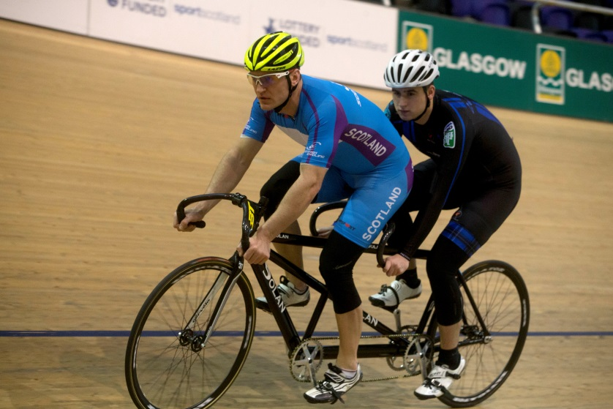

Para cycling sessions are dedicated coaching sessions for riders with physical and learning disabilities who want to keep fit and develop their skills and technique through coached sessions. Both experienced and new riders of age 8+ will be eligible to attend the sessions.
The sessions consist of Solo Riders who are working towards their Accreditation and Tandems who are Piloted (Front rider of Tandem) and Stoked (Rear rider of the tandem).
Fun Facts:
On Track tandems, the front rider steers as well as pedals the bicycle and is known as the captain, pilot, or steersman; the rear rider only pedals and is known as the stoker, navigator or rear admiral. On most tandems the two sets of cranks are mechanically linked by a timing chain and turn at the same rate.

Sir Chris Hoy Velodrome

Paracycling

Do you know of someone that has visual impairment and interested in cycling?
Please speak to our velodrome coach’s or email:gordon.watson@glasgowlife.org.uk for more information on how to book.
Do know of someone that has an interest in piloting a tandem?
If you are a Fully Accredited Adult (Age: 16+) who would like to try and pilot a tandem and assist Piloting a Stoker (Rear rider on one of our tandems), please speak to our velodrome coach’s or email:gordon.watson@glasgowlife.org.uk for more information on how to book.

Sessions run on every Thursday evening.
New and Beginner Riders at 6 pm
Regular and Experienced Riders at 7pm

Sessions are one hour long, limited spaces available!
Sessions are very popular and require advanced booking for Solo/Pilot and Stokers all must be pre booked. You cannot just turn up on the evening and expect to get on the Velodrome.
Solo Riders - 4 riders per hour maximum
Tandem Stokers - 6 riders per hour maximum

Sir Chris Hoy Velodrome

Track Events 2023/2024

November

- Friday 3rd Glasgow Track League 2023/24 Round 5
- Saturday 11th & Sunday 12th Scottish Youth and Junior Championships
- Friday 17th Glasgow Track League 2023/24 Round 7
- Friday 24th Glasgow Track League 2023/24 Round 8

December

- Friday 1st Glasgow Track League 2023/24 Round 9
- Friday 8th to Sunday 10th Scottish Senior Track Championships

January

- Saturday 6th Monsters of Track Round 1
- Saturday 27th & Sunday 28th GTRC Grand Prix

February

- Saturday 10th Monsters of Track Round 2
- Saturday 18th Scottish Madison Championships

March

- Saturday 9th Monsters of Track Round 3

Sir Chris Hoy Velodrome

November 2023 – March 2024 Price List

Adult Sessions (Age 16 +)

Sessions | Duration | Cost
Family Session | 45 Minutes | £8.15
Accreditation 1 | 1 Hour | £15
Accreditation 2 Progression | 1 Hour | £15
Accreditation 3/4 | 2 Hours | £30
DST Endurance | 2 Hours | £17
Sprint/Pursuit | 2 Hours | £17
Adult Coach Led Sprint | 1 Hour | £7
Adult Coach Led Tempo | 1 Hour | £7
Adult Coach Led Interval | 1 Hour | £7
Adult Coach Led Endurance | 1 Hour | £7
Woman Only | 1 Hour | £7
Paracycling Beginners | 1 Hour | £6.10
Paracycling Advanced | 1 Hour | £6.10

Youth Sessions (Age 8 – 15)

Sessions | Duration | Cost
Family Session | 45 Minutes | £5.70
Youth Accreditation 1 | 1 Hour | £10
Youth Accreditation 2 Progression | 1 Hour | £10
Youth Accreditation 3/4 | 2 Hours | £19
Coach Led Youth Session | 2 Hours | £12
Youth Taster Session | 1 Hour | £6

